**EE 2000 Logic Circuit Design  
Semester A 2021/22**

Tutorial 3

1. Use a truth table to present (A + B + C +D)’ = A’ B’ C’ D’

Ans:

1. Implement the following expression with **2-input NAND gates** only:
2. *ABC* + *DE*
3. *ABC + D’ + E*

Ans:

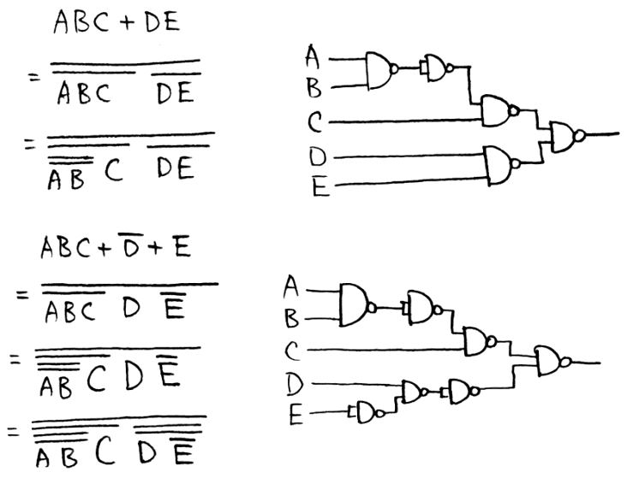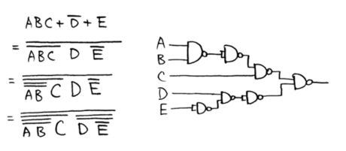

1. Given a truth table:

|  | 1. Express *f* as product of maxterms function in numeric form. 2. Find its MPS form using K-map. 3. From the answer of (b), please design a logic circuit by NAND gates only. |
| --- | --- |

Ans:

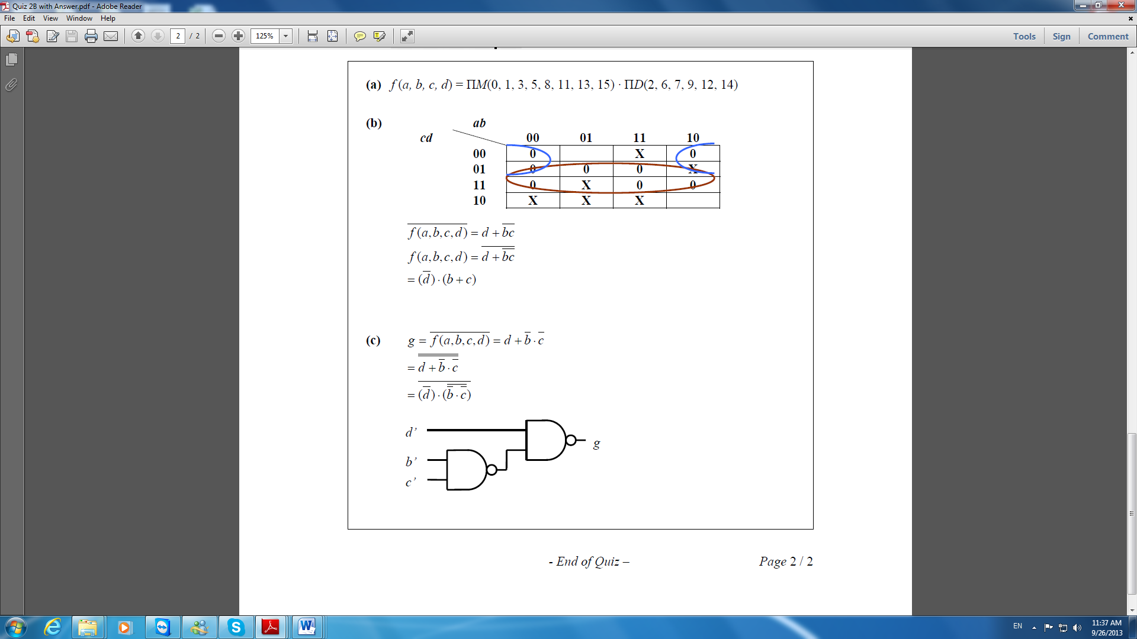

1. Design a combinational circuit for a 3-bit Binary-to-Gray code converter.

Ans:

Circuit:

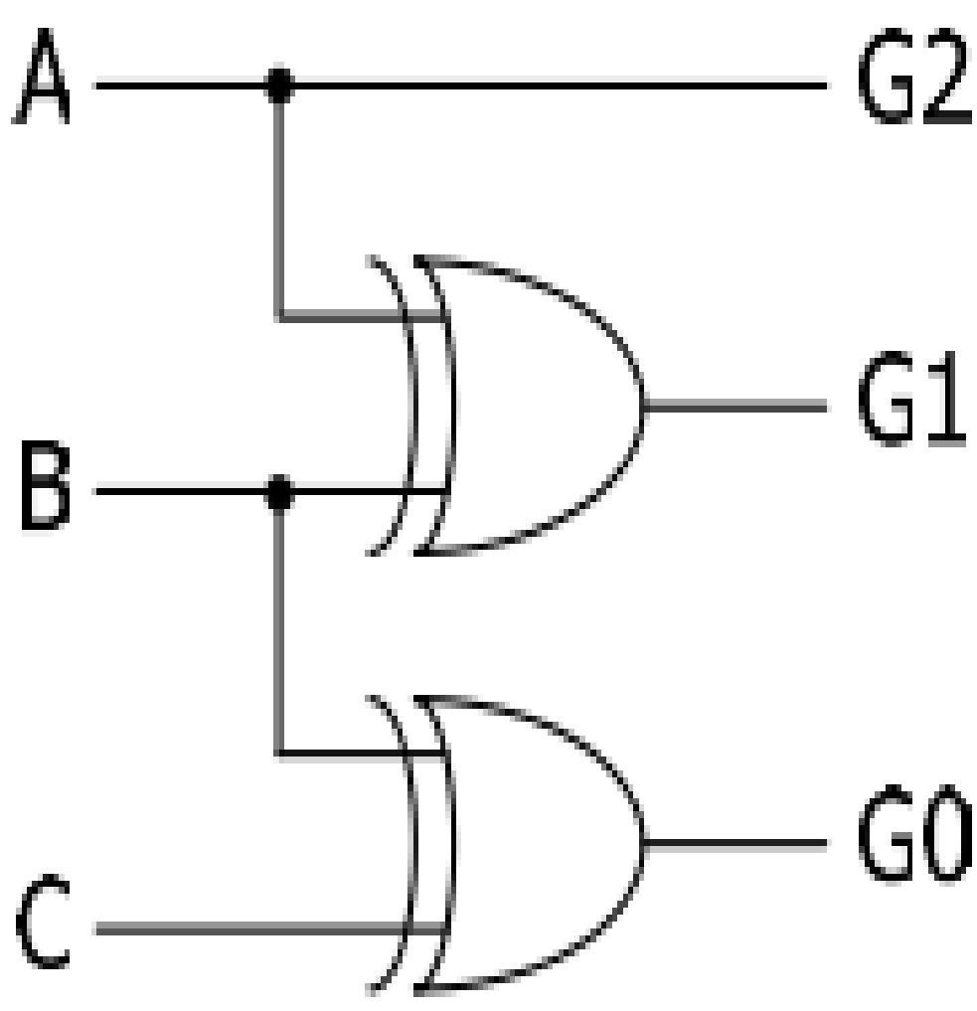

1. Joe, Jack, and Jim get together once a week to either go to a movie or go bowling. To decide what to do, they vote and a simple majority wins. Assuming a vote for the movie is represent as a 1, design a NAND gate circuit that automatically computes the decision.

Ans:

| Joe / x | Jack / y | Jim / z | Decision / *f* |
| --- | --- | --- | --- |
| 0 | 0 | 0 | 0 |
| 0 | 0 | 1 | 0 |
| 0 | 1 | 0 | 0 |
| 0 | 1 | 1 | 1 |
| 1 | 0 | 0 | 0 |
| 1 | 0 | 1 | 1 |
| 1 | 1 | 0 | 1 |
| 1 | 1 | 1 | 1 |

*f* (*x, y, z*) = Σ *m* ( 3, 5, 6, 7) …. By K-map *f* = xy + xz + yz (Please draw the circuit by own)